As part of Archeology Month 2020 archeologists from History Nebraska and the Midwest Archeological Center teamed up with the University of Nebraska Lincoln State Museum to present a virtual program titled “Exploring Earth Lodges”.. As part of the activity one History Nebraska archeologist built a model of a Central Plains tradition square earthlodge. Instructions on how to make your own model are included below.

 Build an Earthlodge Model
Instructions by Nolan Johnson, History Nebraska
and Jennifer Ruyle UNL State Museum
Tools Needed
- Drawing utensil to outline earthlodge shape
- Ruler
- Pruning shears to cut sticks
- Hot glue gun recommended to reinforce walls and help hold sticks together.

Materials Needed
- Foam block
- Sticks
  - Model in picture used about 120 ¼ inch diameter 4 inches long
  - Four ½ inch diameter sticks 6 inches long (center support sticks)
  - Four ¼ inch diameter sticks 12 inches long (cross sticks)
  - 50 ¼ inch sticks about 5 inches long
  - Flexible sticks, green branches, or pipe cleaners to weave between the posts to help hold the clay and sod layers...
- Clay or Playdough
- Dirt with or without grass roots still attached

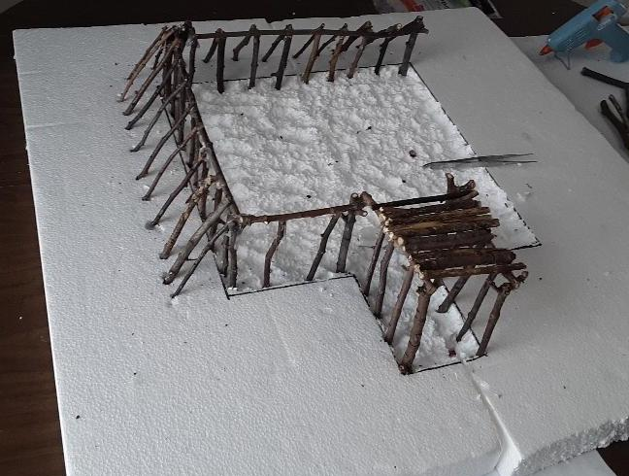

Steps:
- Decide upon the size and shape for your earthlodge. The model pictured above is mostly square with rounded corners and an entrance passage. Some groups made circular lodges as well. Draw an outline of the earthlodge on foam and scoop out some of the interior floor.

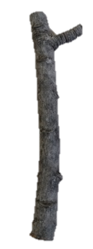
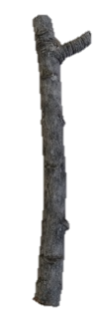
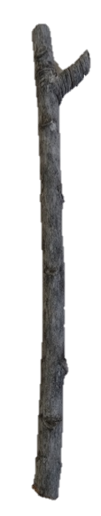
- Build one wall: Find two “y-shaped” sticks and place one at each end of the wall. The “Y” fork should be facing up. Then, place a long cross stick horizontally between the two end posts, resting in the “Y” fork to help make it stable. The cross stick is the top of the wall. Use hot glue or clay to reinforce the wall.

- Add more sticks to the wall: Place additional sticks vertically from the foam to the cross stick about an inch apart. You can glue them to the cross stick to hold them in place. You may want to glue some of the vertical sticks into the foam to make them sturdier.
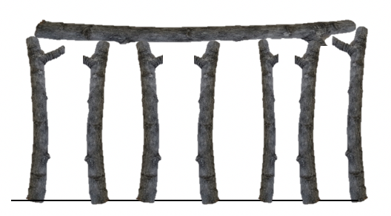

- Place the leaner sticks on the outside of the wall and glue the tops to the cross stick.

- Repeat steps 2-4 for the other walls and steps 2-3 for the entry way.
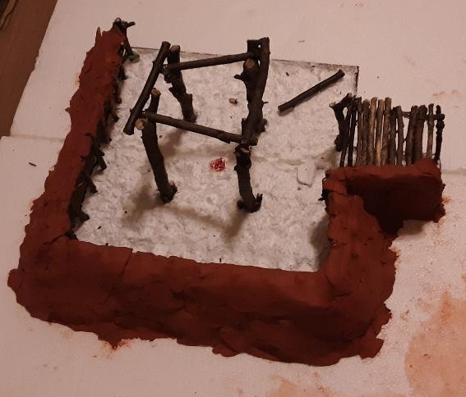
- Glue sticks on the top of the entryway to cover form the entry roof.
Step 6

- Take the four larger 6 inch sticks and use them to form the central supports. They should be placed about half between each corner and the center of your lodge.
Step 7

- Use four sticks to form a square on top of your central supports.

- Glue more sticks onto the square until you have only a small opening in the center which was used to let smoke out of the lodge.

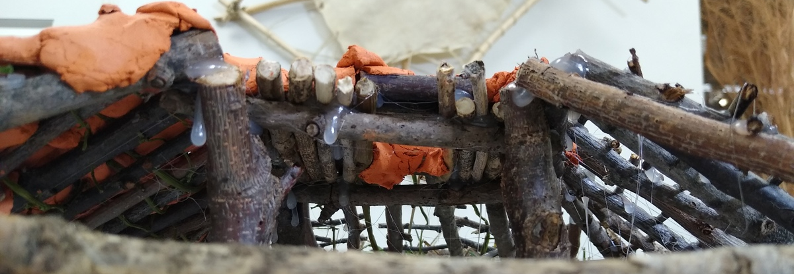
- Take the five inch sticks and place them from the central support to the top of your walls and glue in place.
Step 10
Step 9

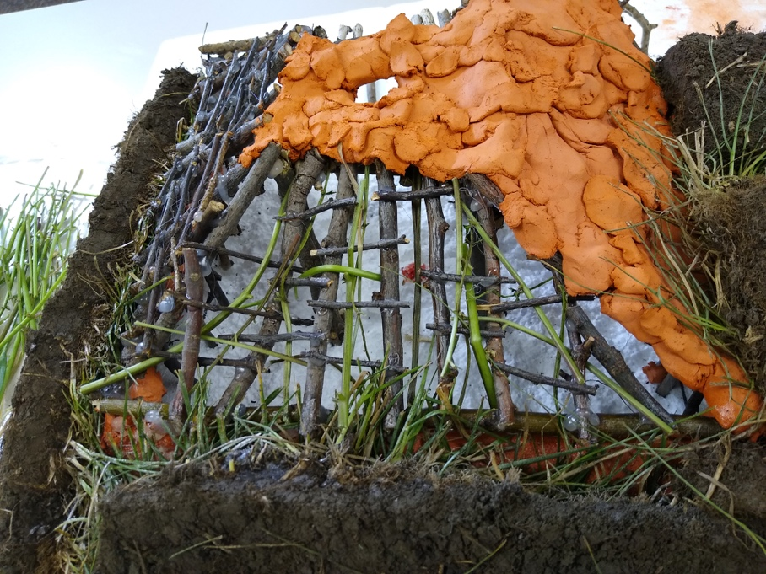
- Take the flexible sticks and weave them between the leaner posts, the walls of your entryway, and the diagonal post spanning from the central supports to the top of the walls.

- Use clay or playdough to cover your lodge except for the door and the smoke hole.

- Take the dirt or sod and pile it up to cover the clay.

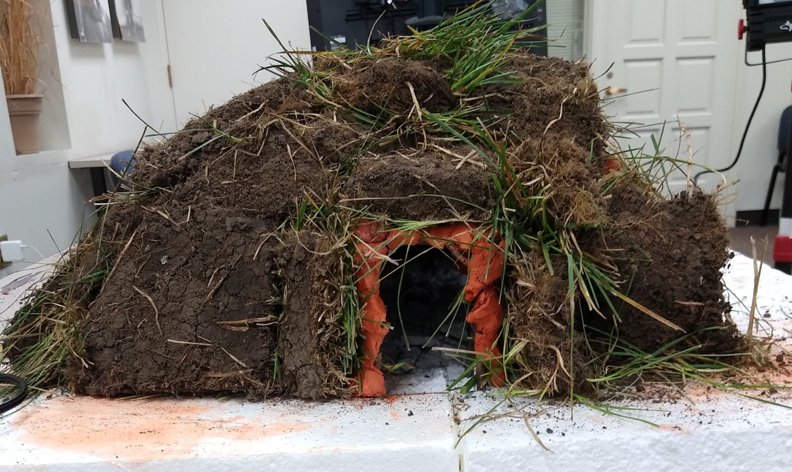

- Take a picture of your completed earthlodge and tag us on social media!
